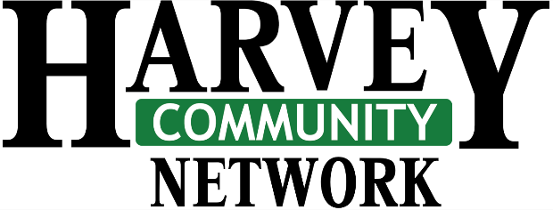
Community organizations are encouraged to submit applications to receive funding from the profits of Harvey Community Days 2023. Please complete the form below (or provide a letter detailing the required information). We ask that you provide most recent annual financial statement / current financial status.

2019 Route 3

Harvey Station, NB E6K 3E9
e-mail: harveycommunitydays@gmail.com

GRANT APPLICATION 2023

Involvement in Harvey Community Days by organizations is greatly appreciated and is included as part of our decision process.

Organization: ______________________________________ Contact Person: __________________________

Mailing Address: ___________________________________ Phone Number: __________________________

___________________________________ Email: __________________________________

___________________________________ Amount of Funding Requested: $ ____________

Please detail how requested funding will be allocated within your organization:

APPLICATION DEADLINE: NOVEMBER 17, 2023
PLEASE E-MAIL OR MAIL TO THE ADDRESS ABOVE.

Supporting the
Community!
Annual profits from Harvey Community Days serve the to support community organizations and local projects.

